1.In the adjointing figure, X and Y are the mid points
of AB and AC respectively. IfQAP//BC then
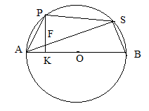
prove that Ar.(ΔABP) = Ar.(ΔACQ).

2.In the figure alongside, O is the centre
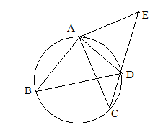
of circle, If ∠APK = ∠PSAthen prove that
(i) PK⊥AB (ii)SFKB is a cyclic quadrilateral.
3.In the figure AB= AC and BD= CE
then prove that: AD= AE.
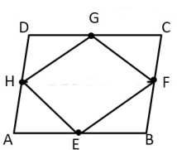
4. In the given figure ABCD is parallelogram E,F,G,H are
the mid points of a side AB,BC,CD and AD
respectively then prove that
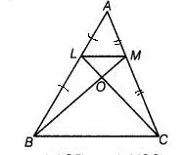
Ar.(EFGH) = Ar.(ABCD)

5. In ΔABC L and M are the mid points of side AB and AC
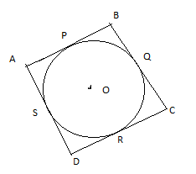
respectively then prove that Ar.( ΔALC)=Ar.( ΔAMB)
6. Prove that the angle between the two tangents drawn from an external point to a circle is supplementary to the angle subtended by the
line segment joining the points of contact at the centre.
7. A quadrilateral ABCD is drawn to circumscribe a circle. Prove
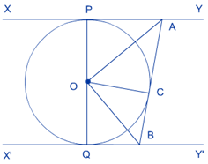
that: AB+CD=AD+BC
8. In the given figure, XY and X’Y’ are two parallel
tangents to a circle with centre O and another tangent
AB with point of contact C intersecting XY at A and X’Y’
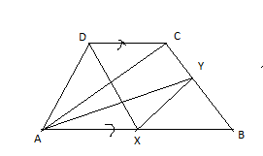
at B. Prove that ∠AOB = 90°
(Hints Showing OA and OB is the angle of bisector of
∠CAP and ∠QBC)
9. In the given figure AB//CD.
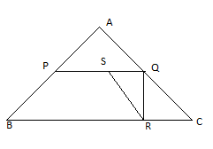
If Ar.(ΔAXD) = Ar.(ΔACY)
then prove that AC// XY.

10. In ΔABC, P and Q are the mid points of AB and AC , S is the mid points of PQ and R is the any point of BC, Prove that: 8ΔSQR= ΔABC.

