Subject: Compulsory Mathematics
Grade: Ten Time: 3hrs F.M: 75
1. रामपुर माध्यमिक विद्यालयका 150 जना विद्यार्थीहरुको गणित र विज्ञान विषयको परीक्षाको सर्वेक्षणमा 50 जना गणितमा उत्तिर्ण भएछन् तर विज्ञानमा उत्तिर्ण भएनछन् त्यस्तै 60 जना विज्ञानमा उत्तिर्ण भएछन् तर गणितमा उत्तिर्ण भएनछन् र 20 जना दुवै विषयमा उत्तिर्ण भएनछन् । (In a survey conducted among 150 students of Rampur Secondary School regarding their mathematics and science exams, 50 students passed mathematics but failed science. Similarly, 60 students passed science but failed mathematics, and 20 students failed both subjects.)
(a) गणितमा उत्तिर्णहुनेलाई M र विज्ञानमा उत्तिर्ण हुनेलाई N मानेर गणितमा मात्र उत्तिर्ण हुने विद्यार्थीहरुको संख्यालाई गणनात्मकतामा लेख्नुहोस् । (Let M represent the students who passed in Mathematics and N represent the students who passed in science. Then write in cardinality number of the set who passed only mathematics.) [1]
Ans: n₀(M)= 50

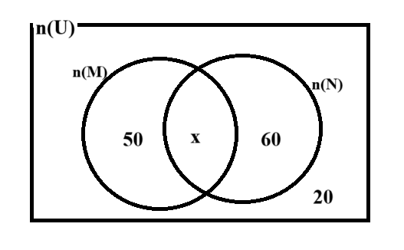
(b) दुवै विषय उत्तिर्णहुने विद्यार्थीसंख्यालाई x मानि माथिको तथ्यलाई भेनचित्रमा देखाउनुहोस् । (Consider the number of students who passed both subjects as x. Represent the above information in a Venn diagram.) [1]
Ans:

(c) भेनचित्रको सहायताले x को मान पत्तालगाई एउटा मात्र विषय उत्तिर्ण हुने विद्यार्थीहरुको संख्या पत्ता लगाउनुहोस् ।(Find the value of x using the Venn diagram and then determine the number of students who passed only one subject) [3]
Ans: 50 + 60 + 20 + x = 150
x + 130 = 150
x= 150-130
x= 20
= n₀(M)+ n₀(N)
= 50+60
=110
(d) यदि दुवै विषयमा अनुत्तिर्ण विद्यार्थीहरुले पुन: गणना गर्दा 10 जना दुवै बिषयमा उत्तिर्ण भएछन् भने कति प्रतिशत बढि विद्यार्थी उत्तिर्ण भएछन्? निकाल्नुहोस् । (If, upon re-totaling, 10 students who initially failed both subjects actually passed both, what is the percentage increase in the number of students who passed at least one subject?) [1]
Ans: The number of pass students = 130+10= 140
The percentage of increase students = $\frac{10}{130}×100\%$
= 7.69%
2. जीवनले आफूसँग भएको रु. 1,50,000 बैंकमा 2 वर्षका लागि राख्ने बिचार गरेछन् । बैंकले दुईओटा विकल्पहरु दिएछ । पहिलो विकल्पमा 10% बार्षिक चक्रिय ब्याज र दोस्रो विकल्पमा 9% अर्धबार्षिक चक्रिय ब्याज रहेछ ।(Jeevan was thinking about depositing Rs. 150,000 in the bank for 2 years. The bank offered two options: the first option was a 10% annual compound interest rate, and the second option was a 9% semi-annual compound interest rate.)
(a) अर्ध वार्षिक चक्रियब्याज पत्ता लगाउने सूत्र लेख्नुहोस् । (Write the formula for finding the semi-annual compound interest.) [1]
Ans:
(b) अर्धबार्षिक चक्रिय ब्याज र अर्धवार्षिक चक्रिय मिश्रधन निकाल्नुहोस् । (Find semi-annual compound interest and amount.) [2]
(c) बार्षिक चक्रिय ब्याज निकाल्नुहोस् । (Find annual compound interest.) [1]
3. 2 वर्ष अघि खरिद गरिएको एउटा ल्यापटपको खरिद मूल्य रु. 80,000 थियो । ल्यापटपको बार्षिक चक्रिय ह्रासदर 15% छ । (The purchase price of a laptop, which was bought 2 years ago, was Rs. 80,000. The laptop has an annual depreciation rate of 15%.)
(a) मिश्रह्रास निकाल्ने सूत्र लेख्नुहोस् । Write the formula to find compound depreciation. [1]
(b) ल्यापटपको हालको मूल्य निकाल्नुहोस् । (Find the present price of the laptop.) [2]
(c) यदि साहुले 10% ह्रासदर राखेर ल्यापटप बेचेको भए कति फाइदा हुन्थ्यो? गणना गर्नुहोस् । (If the shopkeeper had sold the laptop with a 10% depreciation, how much profit would he have made?) [1]
4. चिरीमाया अमेरिका जानेबेला ने.रु. 5,49,000 को अमेरिकी डलर साटिछन् । साट्ने दिनको अमेरिकी डलरको खरिद दर (buying rate): $1 = NRs. 136.65; बिक्रि दर (selling rate): 137.25 छ ।(Chirimaya exchanged Nepalese Rupees 549,000 for US dollars when she was about to go to America. The buying rate for US dollars on that day was $1 = NRs. 136.65, and the selling rate was $1 = NRs. 137.25.)
(a) चिरिमायाले अमेरिकी डलर साट्दा कुन दरमा साटी होलिन् । लेख्नुहोस् ।(At what rate did Chirimaya exchange her Nepalese Rupees for US dollars?) [1]
(b) अमेरिका गएको 2 महिना पछि उनले अमेरिकी डलर ($) 8000 नेपाल पठाईन । उनले नेपाल पैंसा पठाउँदा नेपाली रुपैयाँ 2% ले अवमूल्यन भएको थियो भने उनले नेपालमा कति रुपैयाँ पाठाइन? पत्ता लगाउनुहोस् ।(After 2 months of going to America, she sent US dollars ($) 8000 to Nepal. When she sent money to Nepal, if the Nepalese rupee depreciated by 2%, how many rupees would he send to Nepal? Find out.) [2]
(c) यदि उनले पैंसा पठाउँदा नेपाली रुपैयाँ अमेरिकी डलरको तुलनामा 2% ले अधिमूल्यन भएको भए नेपालमा कति रुपैयाँ बढि वा कम पाउँथिन्? पत्ता लगाउनुहोस् । (If the Nepalese rupee revaluated by 2% against the US dollar when she sent the money, how much more or less rupees would she have received in Nepal? Find out.) [2]
5. एउटा वर्ग आधार भएको पिरामिड आकारको बाकसको आधारको भुजाको लम्बाई 16 m र छड्के सतहको उचाई 10 m छ । (The length of side of base of square base pyramidal box is 16 m.)
(a) उक्त बाकसको पुरा सतहको क्षेत्रफल निकाल्ने सूत्र लेख्नुहोस् ।(Write the formula for finding the total surface of that box.) [1]
(b) उक्त बाकसको ठाडो उचाई निकाल्नुहोस् ।(Find the vertical height of the box.) [1]
(c) उक्त बाकसको आयतन कति हुन्छ? निकाल्नुहोस् ।(What is the volume of that box? Calculate. [2]
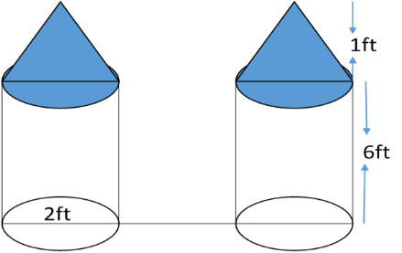
6. दिएको चित्र घरको गेट हो । उक्त गेटको स्वरुप बेलनामाथि सोलीआकारले बनेको छ । गेटको बेलनाकार भागको उचाई 6ft, सोलीको उचाई 1ft र आधारको ब्यास 2ft छ ।(The given picture is the gate of the house. The shape of the gate is cone shaped on a cylinder. The height of the cylindrical part of the gate is 6ft, the height of the cone is 1ft and the diameter of the base is 2ft.)
(a) दिइएको गेटको पुरा सतहको क्षेत्रफल निकाल्नुहोस् ।(Find the total surface area of the gate.) [3]
(b) सोलीको आयतन र बेलनाको आयतनको अनुपात कति हुन्छ? निकाल्नुहोस् (What is the ratio of the volume of the cylinder to the volume of the cone? take out.) [1]
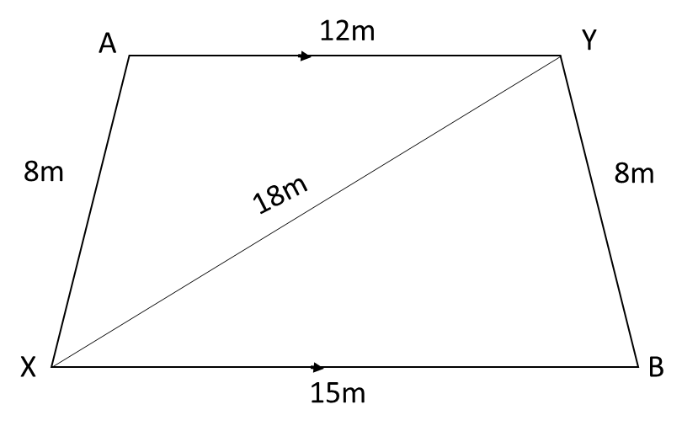
7. एउटा घरको आगन दिइएको आकारको छ । (The courtyard of house is given shaped in figure.)
(a) त्रिभुज ΔAXY को क्षेत्रफल निकाल्ने सूत्र लेख्नुहोस् ।(Find the area ΔAXY.[1]
(b) उक्त आगनमा 0.5 m² का ब्लकहरु छाप्दा कतिओटा ब्लक लाग्ला? निकाल्नुहोस् ।(How many blocks of 0.5 m² will be required to cover the given courtyard? Calculate.) [2]
(c) प्रति ब्लक रु. 50 र प्रति कामदार रु.1500 प्रतिदिनका दरले 2 जना कामदारले 2 दिनमा उक्त ब्लक छाप्न सक्छन् भने जम्मा कति खर्च आउला? निकाल्नुहोस् । (If 2 workers can cover the blocks in 2 days at a rate of Rs. 50 per block and Rs. 1500 per worker per day, then what will be the total cost? Calculate.) [2]
8. एक जना मानिसले आफ्नी छोरीको बैंक खातामा गुणोत्तर श्रेणीअनुसार 6 महिनाका लागि रुपैयाँ जम्मा गर्दा सुरुमा महिनामा रु. 50 र अन्तिम महिनामा रु. 12,150 जम्मा गरेछन् ।(A man depositing rupees in his daughter's bank account for 6 months according to the geometric series, initially Rs. 50 and in the last month Rs. 12,150 have collected.)
(a) 50 र 12150 को बीचमा जम्मा कतिओटा गुणोत्तर मध्यमा छन्? लेख्नुहोस् । (How many geometric means are there between 50 and 12150? write.) [1]
(b) रुपैयाँ जम्मा गर्दा कुन अनुपातमा जम्मा गरेका रहेछन्? पत्ता लगाउनुहोस् । (When collecting rupees, what ratio have been deposited? Find out.)[2]
(c) उनले छोरीको बैंक खातामा जम्मा कति रुपैयाँ जम्मा गरेछन् । पत्ता लगाउनुहोस् । (How many rupees has he deposited in his daughter's bank account? Find out.)[2]
9. एउटा आयताकार जग्गाको लम्बाई चौडाईभन्दा 4m ले बढी छ । उक्त जग्गाको क्षेत्रफल 320 m² छ । (The length of a rectangular field is 4 m more than its breadth and area is 320 m².)
(a) यदि लम्बाई x भए चौडाई लाई x को रुपमा लेख्नुहोस् ।(If the length is x, then write the breadth as the form of x.) [1]
(b) उक्त जग्गाको लम्बाई र चौडाई पत्ता लगाउनुहोस् । (Find the length and breadth of the field.) [2]
(c) यदि चौडाईतिर 1 m बढाईयो भने क्षेत्रफलमा कतिप्रतिशत ले बढि हुन्छ? निकाल्नुहोस् ।(If the breadth is increased by 1 m, by what percent will the area increase? Calculate.) [1]
10. (a) सरल गर्नुहोस् ।(Simplify): $\frac{x-y}{x^{2}-xy+y^{2}}+\frac{y^{3}}{x^{4}+x^{2}y^{2}+y^{4}}$. [2]
(b) हल गर्नुहोस् । (Solve): $7^{x}+\frac{1}{7^{x}}=7\frac{1}{7}$. [3]
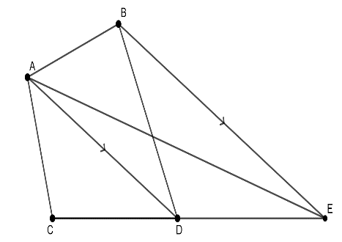
(c) x‍=2 ले $4^{-x}+4^{x}=16\frac{1}{16}$लाई सन्तुष्ट गर्छ भन्ने कुराको पुष्टि गर्नुहोस् । (Justify that x=2 satisfies to $4^{-x}+4^{x}=16\frac{1}{16}$) [1]
11. दिइएको चित्रमा AD//BE छ । (In the given figure AD//BE.)
(a)ΔADB र ΔADE बीचको सम्बन्ध लेख्नुहोस् । (Write the relation between ΔADB and ΔADE.) [1]
(b) प्रमाणित गर्नुहोस् (Prove that): Quadrilateral ABDC= ΔACE. [2]
(c) यदि विन्दु D रेखा CE को मध्य विन्दु भए ΔACD र ΔACE को सम्बन्ध कारण सहित लेख्नुहोस् । If point D is mid-point of line CE then write the relation between ΔACD and ΔACE with reason. [1]
12. (a) AB = 6cm, BC = 6.5 cm र AC=7cm भएको एउटा त्रिभुजको रचना गरी उक्त त्रिभुजसँग बराबर क्षेत्रफल हुने र एउटा भुजा DF = 7.5cm भएको समानान्तर चतुर्भुज DBEF को रचना गर्नुहोस् । [3]
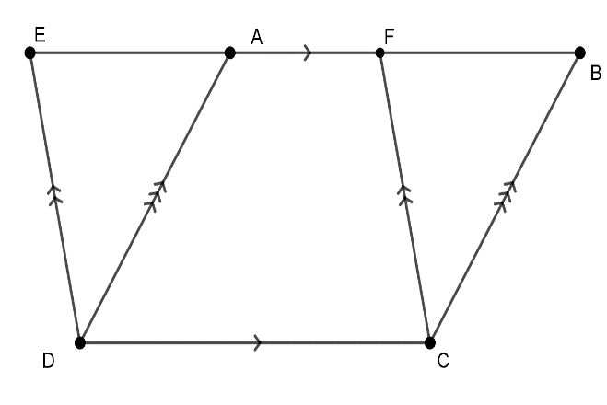
(b) दिइएको चित्रमा यदि EB//DC, DE//CF र DA//CB भए ΔADE र ΔBCF को क्षेत्रफल बराबर हुन्छ भनी प्रमाणित गर्नुहोस् । (In the given figure, if EB//DC, DE//CF and DA//CB, then prove that the area of ΔADE is equal to the area of ΔBCD.) [2]
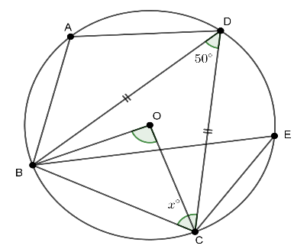
13. दिइएको चित्रमा O वृत्तको केन्द्रविन्दु हो । AD=CD र $∡BDC={50}^{0}$ छ । (In the figure O is the centre of the circle. AD=CD and AD=CD र $∡BDC={50}^{0}$.
(a) $∡BDC र ∡BOC$ बीचको सम्बन्ध लेख्नुहोस् । (Write the relation of $∡BDC and ∡BOC$.) [1]
(b) $∡BCD=x^{o}$ को मान पत्ता लगाउनुहोस् । (Find the value of $∡BCD=x^{o}$ . [2]
(c) वृत्तका परिधिकोणहरु ∠BDC र ∠BEC को मान बराबर हुन्छ भनि प्रयोगद्वारा सिध्द गर्नुहोस् । (कम्तीमा 3cm अर्धव्यासका दुईओटा वृत्त अनिवार्य छन् ।) (Prove experimentally that ∠BDC and ∠BEC are equal.) (At least two circles of radius 3 centimeters are mandatory) [2]
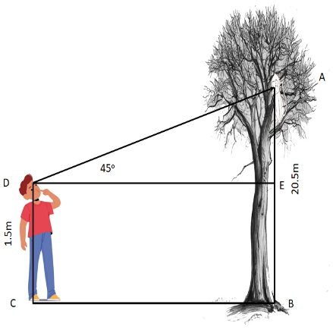
14. 1.5 m उचाई भएको एउटा केटोले जमिनबाट 20.5m उचाईमा बसेको बाँदरलाई हेर्दा ${45}^{0}$ पाएछ । (A boy 1.5 m tall finds ${45}^{0}$ when looking at a monkey sitting 20.5 m above the ground.)
(a) उन्नतांश कोण र अवनति कोणको बीच कुनै एक फरक लेख्नुहोस् । (Write any one difference between angle of elevation and angle of depression.) [1]
(b) बाँदर केटोभन्दा कति माथिको उचाईमा बसेको छ? निकाल्नुहोस् ।(How much higher is the monkey sitting than the boys height? Find out.) [1]
(c) केटो र रुख बीचको दूर पत्ता लगाउनुहोस् । (Find the distance between boy and tree.) [1]
(d) बाँदर अहिलेको स्थानबाट कति मिटर तल आउँदा केटो र बाँदर बीच बन्ने उन्नतांश कोण ${30}^{0}$ हुन्छ? पत्ता लगाउनुहोस् ।(When the monkey descends how many meters from its current position, the angle of elevation formed between the boy and the monkey is ${30}^{0}$ ? Find out.) [1]

15. 75 पूर्णाङ्को गणित विषयको परीक्षामा 56 जनाले निम्नानुसारको अङ्क प्राप्त गरेका छन् ।(In a mathematics exam of 75 full marks, 56 people have obtained marks as follows.)
प्राप्ताङ्क(Marks obtained) | 0-15 | 15-30 | 30-45 | 45-60 | 60-75
विद्यार्थी सङ्ख्या (No. of students) | 5 | 12 | 21 | 10 | 8
दिइएको तथ्याङ्कको पहिलो चतुर्थांश निकाल्ने सूत्र लेख्नुहोस् । (Write down the formula to find first quartile of the given data.) [1]
सञ्चित बारम्बारता तालिका निर्माण गर्नुहोस् । (Construct the cumulative frequency table.) [2]
पहिलो चतुर्थांश (Q₃)पत्ता लगाउनुहोस् । (Find the third quartile (Q₃). [2]
दिइएको तथ्याङ्कमा बहुलक(रित) पर्ने श्रेणीको माथिल्लो सिमा पत्ता लगाउनुहोस् । (What is the upper limit of the modal class) [1]
16. 1 देखि 30 सम्मका अङ्क पत्तीहरुबाट नहेरी दुईओटा पत्ती एक पछि अर्को पुन: नराखि थुतिएको छ । (Two cards are drawn randomly from the pack of card numbered from 1 to 30 one after the another without replacing).
(a) सम्भाव्यताको अधिकतम मान कति हुन्छ? लेख्नुहोस् । (What is the maximum value of probability? Write.) [1]
(b) पहिलो पत्ती 5 को अपवर्त्य पर्ने सम्भाव्यता कति हुन्छ? पत्ता लगाउनुहोस् । What is the probability that the first card is the multiple of 5? Find it. [1]
(c) उक्त अङ्क पत्तीबाट 5 को अपवर्त्य र 7 का अपवर्त्य पर्ने सबै सम्भावित परिणामको सम्भाव्यतालाई वृक्षचित्रमा देखाउनुहोस् । (Show the probability of all possible outcomes of multiples of 5 and multiples of 7 from the given number card in a tree diagram.) [2]
(d) दुबै अङ्क पत्तीहरु 7 का अपवर्त्य र 5 का अपवर्त्य पर्ने सम्भाव्यताको फरक कति हुन्छ? निकाल्नुहोस् । (What is the difference in probability between both number cards being multiples of 7 and both number cards being multiples of 5? Calculate) [1]
“The End”

